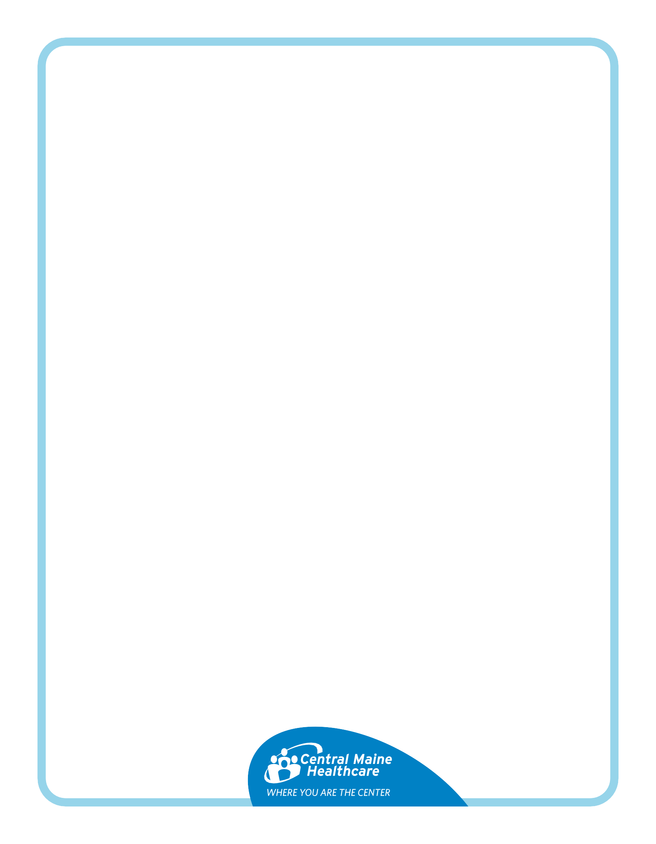
EGD Instructions

Your doctor scheduled an EGD (upper endoscopy) to check your esophagus, stomach, and upper intestine using a thin, flexible tube called an endoscope.

During the procedure, your doctor may: ✔ Take tissue samples ✔ Remove stuck food ✔ Stop bleeding ✔ Open narrowed areas

Questions?

Ask the doctor who scheduled your test.

Day of Your Test

- Take your regular medicines with a small sip of water at least 2 hours before arrival (unless told otherwise).
- 🚫 No food after midnight.
- You may drink clear liquids until 2 hours before arrival.
- 🚫 No gum or candy after midnight.

Allowed Clear Liquids
✔ Clear soups: broth (chicken, beef, vegetable), consommé
✔ Drinks: tea, coffee (no milk), soda, Crystal Light, Gatorade
✔ Juices: apple, white grape, white cranberry (NO orange or grapefruit juice)
✔ Treats: Jell-O, popsicles (no milk), Italian ice

NO FOOD, DRINKS, OR WATER WITHIN 2 HOURS OF YOUR ARRIVAL TIME! DOING SO COULD RESULT IN A DELAY OR CANCELLATION OF YOUR PROCEDURE!

