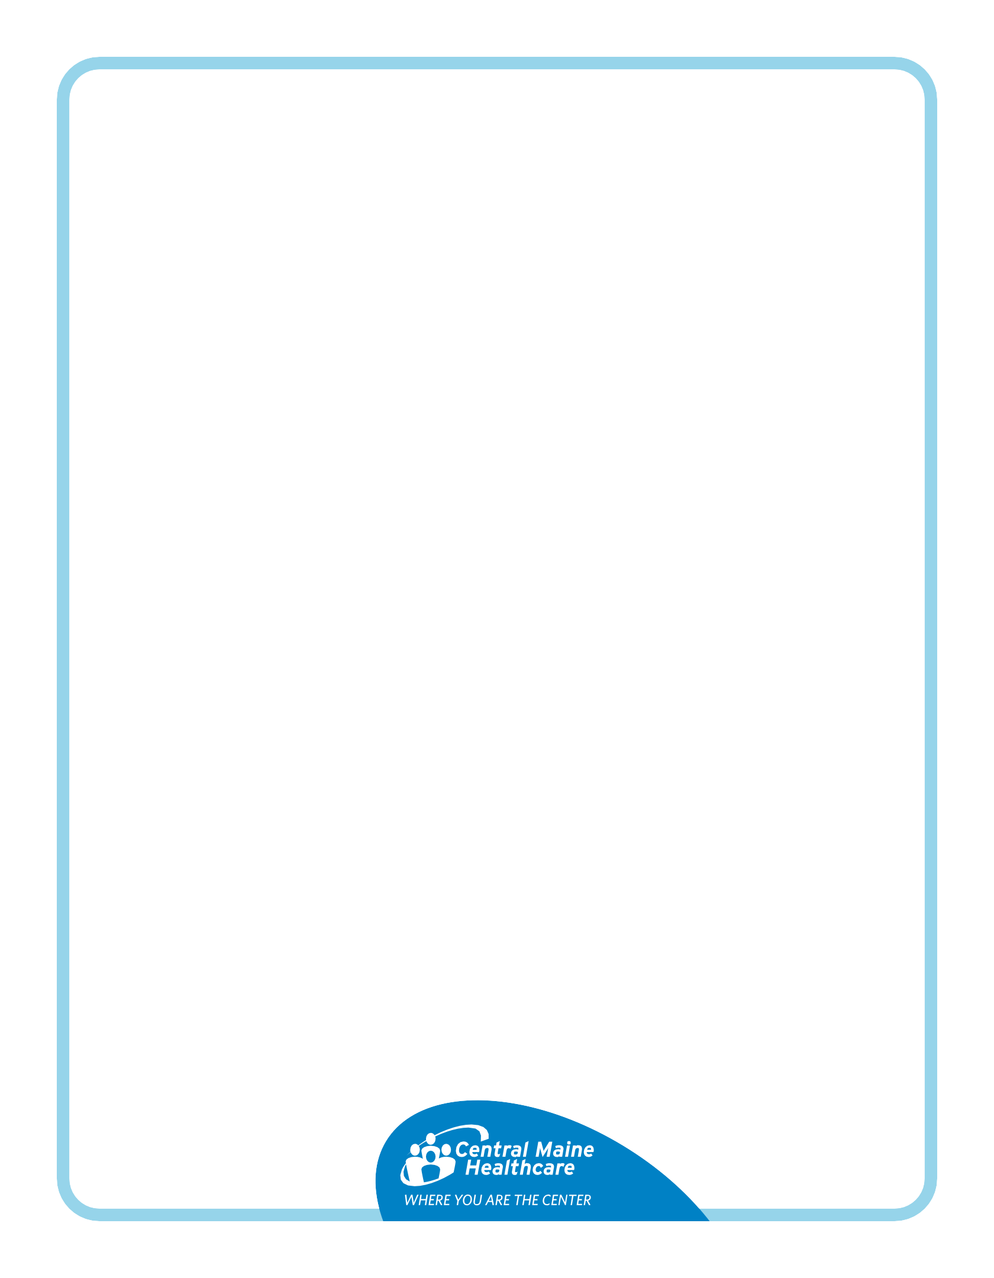
Colonoscopy(Suprep) and EGD Instructions

You are scheduled for two procedures:
- EGD (Esophagogastroduodenoscopy) – A doctor checks your esophagus, stomach and upper intestines using a tube with a camera. They may take tissue samples, remove stuck food, stop bleeding or widen narrow areas.
- Colonoscopy – A doctor examines your large intestine for polyps, cancer and other health problems. They may remove polyps or early signs of cancer.

Preparation is key. You need to clean out your colon before your procedure. Otherwise, your doctor might miss something or need to reschedule your appointment.

What do you need? SuPrep: Your doctor sent a prescription to your pharmacy.

5 days before your procedure:
- Stop taking vitamins, fiber, iron and herbal supplements.
- Keep taking your prescription medications unless told otherwise.
- Eat a low-fiber diet: limit grains, fruits and vegetables.

✅ You can eat:
- White bread, crackers, pasta, white rice | - Certain fruits: ripe bananas, peaches, honeydew
- Cooked potatoes | - Well-cooked vegetables
- Dairy: yogurt, cheese, cottage cheese | - Meat: chicken, fish, beef

❌ Avoid:
- Dried fruit, nuts, seeds | - Whole wheat/grain, granola, brown rice, oats
- Raw vegetables, beans

The day before your procedure: It is normal to feel chilly while prepping
✅ You can drink the clear liquids below all day - no solid food!
- Soda, sparkling water, electrolyte drinks | - Clear juices (no pulp)
- Tea or coffee (no milk or cream) | - Popsicles, Jell-O, Italian ice (no dairy)
- Clear broth: chicken, vegetable, beef

❌ Avoid:
- Red-colored drinks - the dye interferes with the procedure.

At 6:00 p.m.:
1) Pour one bottle of SuPrep into the container.  2) Add water or clear liquid to the 16-ounce line. | 3) Drink it all! If it tastes bad, dilute with extra water.  4) Drink 32 ounces of water over the next hour.

On the day of your procedure:
At least four hours before arrival:
- Take your normal medications with a  little water, unless told otherwise.  2) Pour next bottle of SuPrep into the container.  3) Add water to 16-ounce line, mix, drink it all. | 4) Drink 32 ounces of water over the next hour.  5) Stop drinking at least two hours before arriving.  6) Your stool should be clear or yellow with no solid pieces.  You should see the bottom of the toilet clearly.
❌ No food, drinks or water after finishing prep! If your stool isn’t clear, call 207-795-2790.

