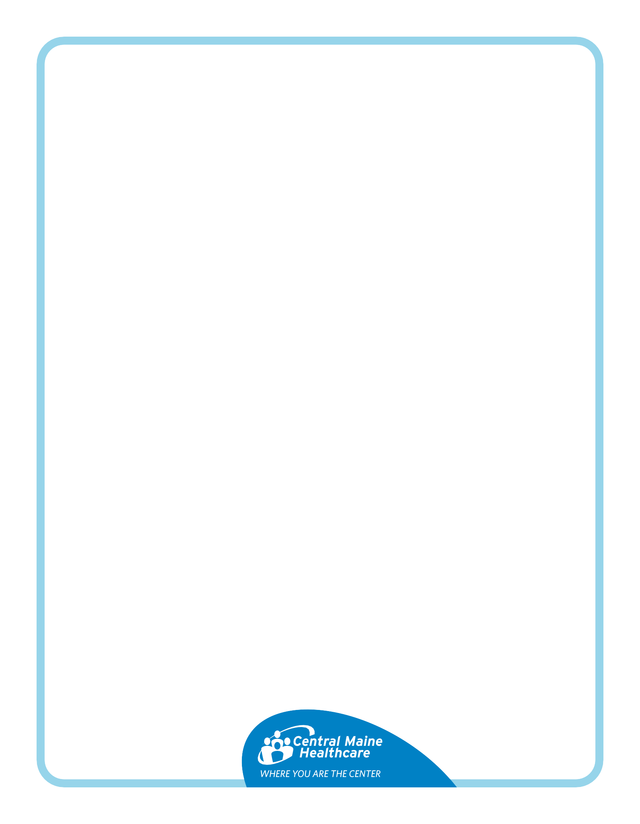
EGD with VCE Drop in Instructions

You have a Video Capsule Drop-in with an EGD scheduled.
- EGD (Esophagogastroduodenoscopy) is a test that helps doctors check for problems in your digestive system. It's also called an upper scope or upper endoscopy.
- Video Capsule is a tiny camera inside a capsule that you swallow. It takes thousands of pictures as it moves through your digestive tract. These pictures are sent to a data recorder, and the capsule will leave your body naturally in a few days.

Questions?

Ask the doctor who scheduled your test.

What do you need?: 1 bottle of MiraLax (or generic equivalent) available in any pharmacy near the laxatives

7 Days before your procedure:
- ❌ Stop taking any oral iron

The day before your procedure:
- Breakfast will be your only regular meal of the day
- Following breakfast, you will need to follow a clear liquid diet for the rest of the day.

- Allowed Clear Liquids
- ✔ Clear soups: broth (chicken, beef, vegetable), consommé
- ✔ Drinks: tea, coffee (no milk), soda, Crystal Light, Gatorade
- ✔ Juices: apple, white grape, white cranberry (NO orange or grapefruit juice)
- ✔ Treats: Jell-O, popsicles (no milk), Italian ice

❌ Avoid:
- Red-colored drinks - the dye interferes with the procedure.

4:00pm day before your procedure:
- Take MiraLax (or equivalent) 3 capfuls diluted in 16 oz of water within ½ hour. Continue to drink clear liquids

Day of Your Test

- Take your regular medicines with a small sip of water at least 2 hours before arrival (unless told otherwise).
- 🚫 No food after midnight.
- You may drink clear liquids until 2 hours before arrival.
- 🚫 No gum or candy after midnight.
After your procedure:
- You will be provided with instructions for the remainder of the exam day by the clinical staff in endoscopy
- Equipment MUST be returned to Central Maine Gastroenterology located at 77 Bates Street, Lewiston, ME 04240

NO FOOD, DRINKS, OR WATER WITHIN 2 HOURS OF YOUR ARRIVAL TIME! DOING SO COULD RESULT IN A DELAY OR CANCELLATION OF YOUR PROCEDURE!

