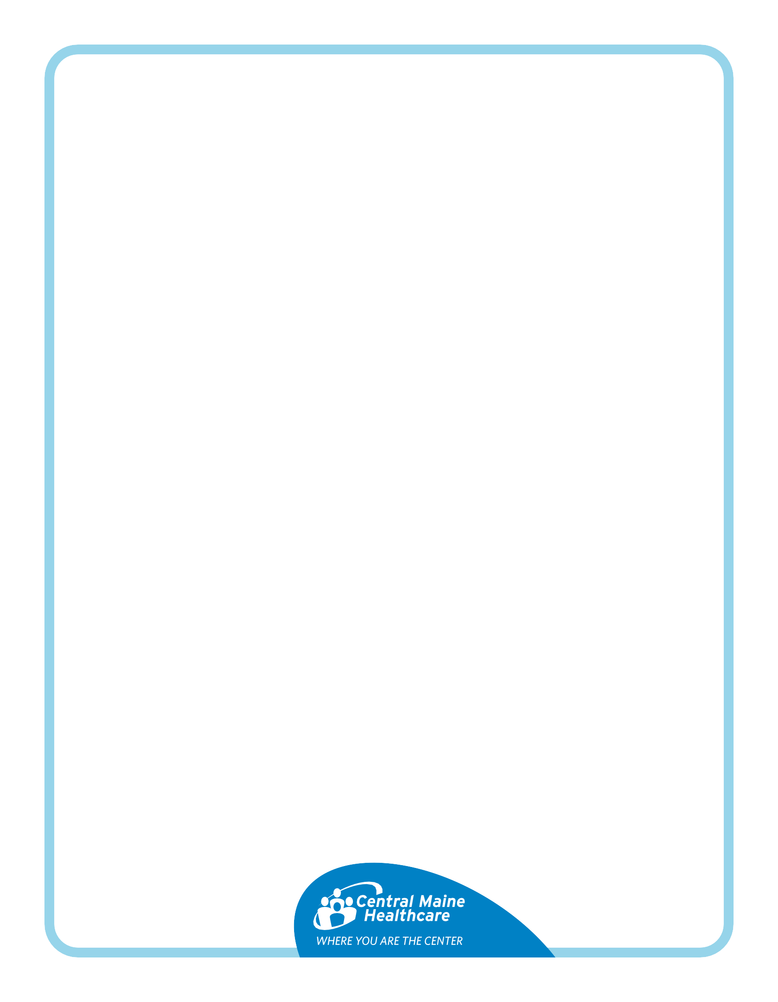
Colonoscopy(Miralax) and EGD Instructions

You are scheduled for two procedures:
- EGD (Esophagogastroduodenoscopy) – A doctor checks your esophagus, stomach and upper intestines using a tube with a camera. They may take tissue samples, remove stuck food, stop bleeding or widen narrow areas.
- Colonoscopy – A doctor examines your large intestine for polyps, cancer and other health problems. They may remove polyps or early signs of cancer.

Preparation is key. You need to clean out your colon before your procedure. Otherwise, your doctor might miss something or need to reschedule your appointment.

What do you need?: MiraLAX (or generic brand) – one 238-gram bottle
Gatorade (no red flavors) – one 64-ounce bottle

5 days before your procedure:
- Stop taking vitamins, fiber, iron and herbal supplements.
- Keep taking your prescription medications unless told otherwise.
- Eat a low-fiber diet: limit grains, fruits and vegetables.

✅ You can eat:
- White bread, crackers, pasta, white rice | - Certain fruits: ripe bananas, peaches, honeydew
- Cooked potatoes | - Well-cooked vegetables
- Dairy: yogurt, cheese, cottage cheese | - Meat: chicken, fish, beef

❌ Avoid:
- Dried fruit, nuts, seeds | - Whole wheat/grain, granola, brown rice, oats
- Raw vegetables, beans

The day before your procedure: It is normal to feel chilly while prepping
✅ You can drink the clear liquids below all day - no solid food!
- Soda, sparkling water, electrolyte drinks | - Clear juices (no pulp)
- Tea or coffee (no milk or cream) | - Popsicles, Jell-O, Italian ice (no dairy)
- Clear broth: chicken, vegetable, beef

❌ Avoid:
- Red-colored drinks - the dye interferes with the procedure.

At 5:00 PM:
- Mix the MiraLAX into the Gatorade and shake.
- Drink 1 cup (8 ounces) every 15 minutes until half of the bottle is gone.
- Put the rest in the fridge for the morning.
- If you feel sick, stop for 45 minutes and then keep going.
On the day of your procedure:
1) Take your normal medications with a little water, unless told otherwise
2) Drink the rest of your MiraLAX and Gatorade mix (1 cup every 15 minutes).
3) Finish drinking at least 2 hours before your appointment.
4) Your stool should be clear or yellow with no solid pieces. You should see the bottom of the toilet clearly.

❌ No food, drinks or water after finishing prep! If your stool isn’t clear, call 207-795-2790.

