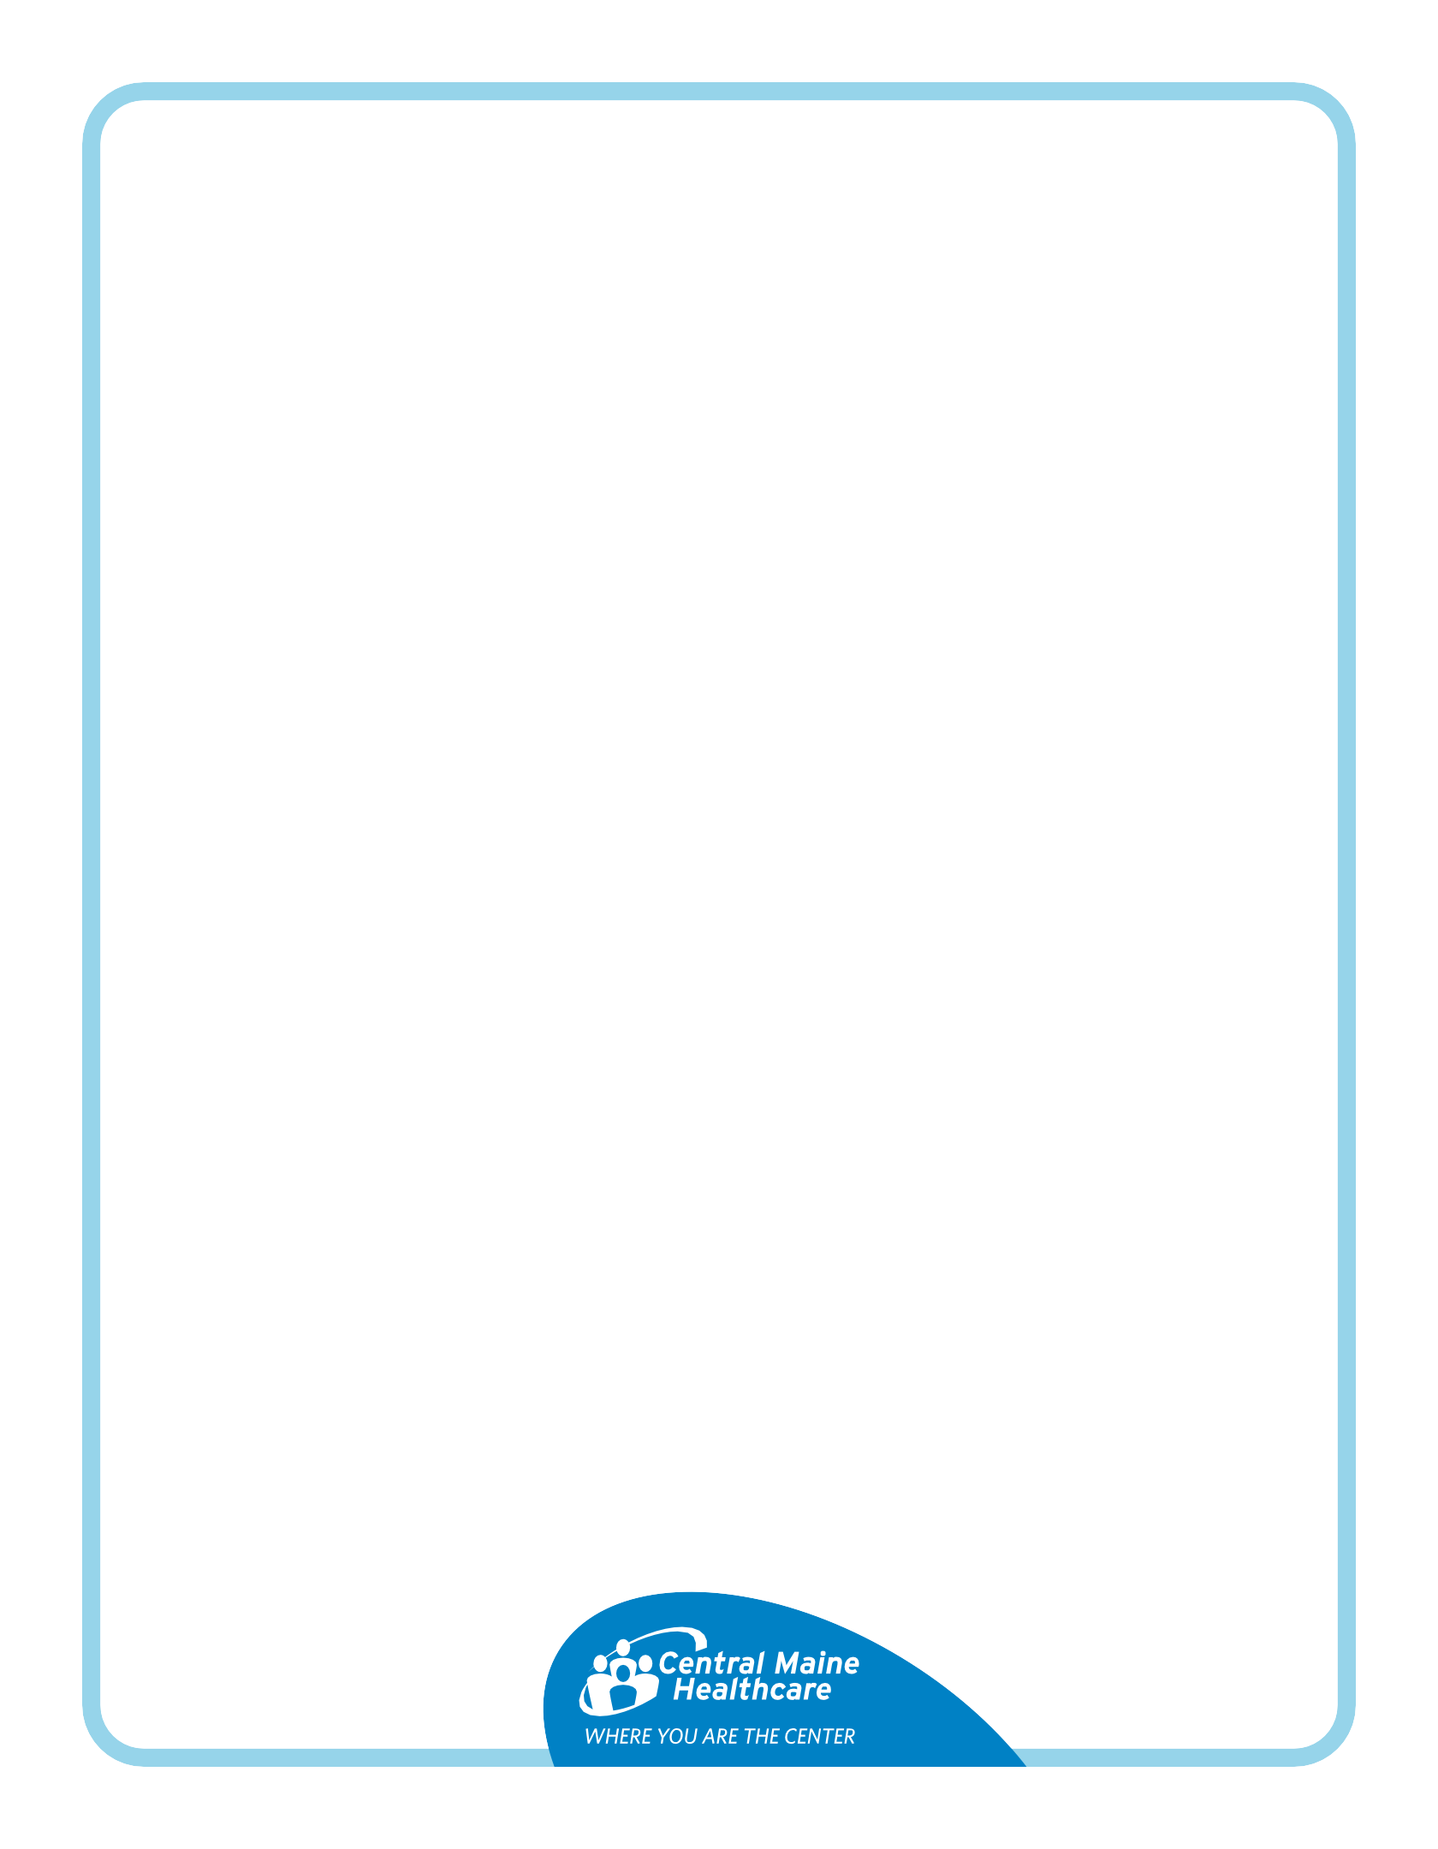
About Your EGD with Bravo Procedure

Your doctor scheduled a Bravo pH Study with an EGD (upper endoscopy) to check how often stomach acid backs up into your esophagus. To get accurate results, live your normal routine — eat, drink, work and exercise as usual.

During the procedure, a small capsule will be placed in your esophagus. You'll take home a monitor to track acid levels. The capsule will pass on its own; please return the monitor to the hospital for results.

Questions?
Ask the doctor who scheduled your test.

7 days before your test:
✅ You can take:
- Tums, unless your doctor says otherwise.

🚫 Stop:
- All antacids (like Prilosec, Nexium, Pepcid, Omeprazole, Pantoprazole, Famotidine).

The day before your test:
🚫 Stop:
- Taking Tums if you used them for reflux.

On the day of your test:
- Take your normal medications at least 2 hours before arrival, with a little water, unless told otherwise.
- No food after midnight.
- You may drink clear liquids until 2 hours before arrival time.
- No gum or candy after midnight.

You can drink the clear liquids below until 2 hours before arrival time:
- Clear soups: broth (chicken, beef, vegetable), consommé
- Drinks: tea, coffee (no milk), soda, Crystal Light, Gatorade
- Juices: apple, white grape, white cranberry (NO orange or grapefruit juice)
- Treats: Jell-O, popsicles (no dairy), Italian ice

NO FOOD, DRINKS, OR WATER WITHIN 2 HOURS OF YOUR ARRIVAL TIME! DOING SO COULD RESULT IN A DELAY OR CANCELLATION OF YOUR PROCEDURE!

